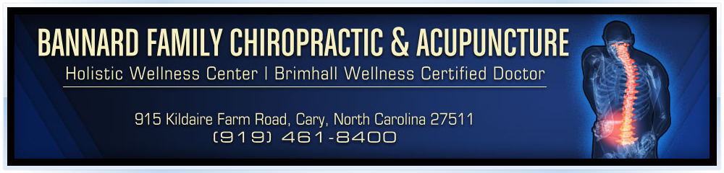

Informed Consent to an "Unproven" Procedure
This consent form identifies those services or procedures performed in this office that are designated "unproven" by the North Carolina State Board of Chiropractic Examiners and their effectiveness has not been demonstrated. "Unproven” means that the service or procedure is one that is not generally recognized or does not have scientific validity whose research was not sponsored and investigative findings have not been printed in scientific journals.
By signing this form, the patient grants permission for the practice to proceed with the rendering of these services on an as needed basis.
Services rendered in this practice that are designated as "unproven" by the State Board of Chiropractic Examiners includes:
-Soft or Cold Laser therapy for uses not approved by the Food and Drug Administration
-Reflexology or the testing of Reflex Points
-Eyelights
-Color and Sound Therapy
-EB Pro Detox Footbath
-PEMF (Pulse Electro Magnetic Field therapy)

By signing this consent I, _________________________________________ understand that the procedure(s) referenced have been designated as "unproven" by the North Carolina State Board of Chiropractic Examiners and the effectiveness has not been demonstrated. I also understand that by signing this waiver, I consent to the use of or rendering of these services by this practice on an as needed or as recommended basis and I grant my doctor permission to proceed with these services. I also understand that at any time I can elect to discontinue the receipt of these services by informing my doctor or staff member of my decision.
______________________________________________ ____________________
(Print Name) Date
________________________________________________________
(Signature)

